Abstract— Short abstract - specify problem, describe your solution and summarize results in a few sentences.
Title of your semestral work
Author Name

INTRODUCTION
THIS report should be introduced by description of your assignment as communicated with your supervisor and introduction to the problem which is being solved.

Methodology

Setup of experiments
Describe setup of your experiments, ...

Configuration of algorithms
Configuration of algorithms, tools used

Experiments

Describe your experiments here, each figure/table should be explained and interpreted ...
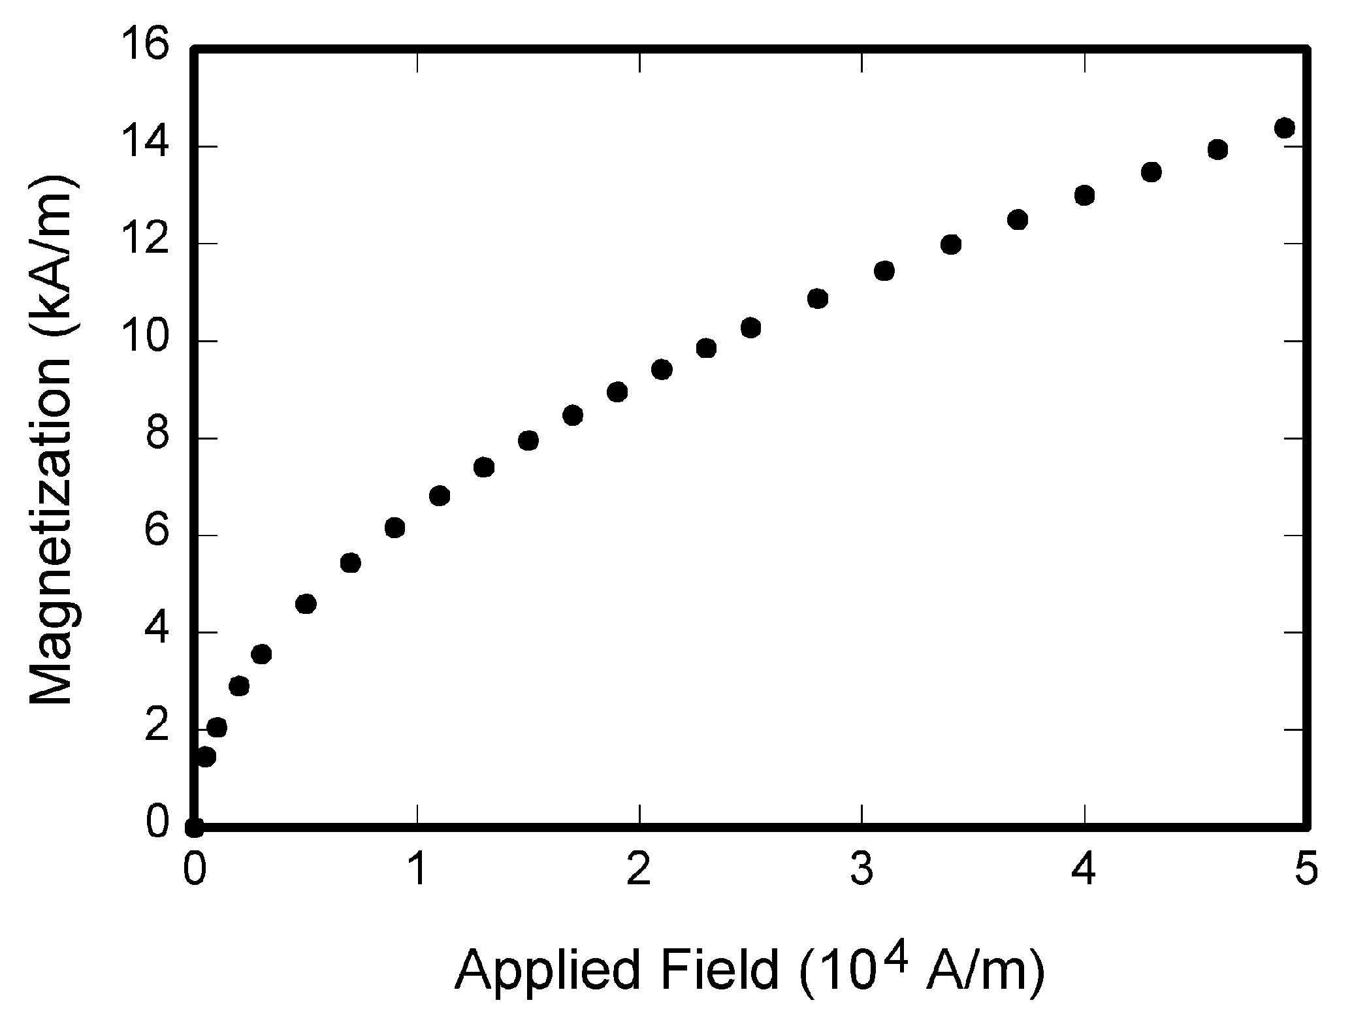
Fig. 1. Magnetization as a function of applied field. Note that “Fig.” is abbreviated. There is a period after the figure number, followed by two spaces. It is good practice to explain the significance of the figure in the caption.

Disscusion
Discuss your results here.

Conclusion
TABLE I
Units for Magnetic Properties
Symbol | Quantity | Conversion from Gaussian and  CGS EMU to SI ª
Φ | magnetic flux | 1 Mx → 10⁻⁸ Wb = 10⁻⁸ V·s
B | magnetic flux density,  magnetic induction | 1 G → 10⁻⁴ T = 10⁻⁴ Wb/m²
H | magnetic field strength | 1 Oe → 10³/(4π) A/m
m | magnetic moment | 1 erg/G = 1 emu  → 10⁻³ A·m² = 10⁻³ J/T
M | magnetization | 1 erg/(G·cm³) = 1 emu/cm³  → 10³ A/m
4πM | magnetization | 1 G → 10³/(4π) A/m
σ | specific magnetization | 1 erg/(G·g) = 1 emu/g → 1 A·m²/kg
j | magnetic dipole  moment | 1 erg/G = 1 emu  → 4π × 10⁻¹⁰ Wb·m
J | magnetic polarization | 1 erg/(G·cm³) = 1 emu/cm³  → 4π × 10⁻⁴ T
χ, κ | susceptibility | 1 → 4π
χ_{ρ} | mass susceptibility | 1 cm³/g → 4π × 10⁻³ m³/kg
μ | permeability | 1 → 4π × 10⁻⁷ H/m  = 4π × 10⁻⁷ Wb/(A·m)
μ_{r} | relative permeability | μ → μ_{r}
w, W | energy density | 1 erg/cm³ → 10⁻¹ J/m³
N, D | demagnetizing factor | 1 → 1/(4π)
No vertical lines in table. Statements that serve as captions for the entire table do not need footnote letters.
ªGaussian units are the same as cgs emu for magnetostatics; Mx = maxwell, G = gauss, Oe = oersted; Wb = weber, V = volt, s = second, T = tesla, m = meter, A = ampere, J = joule, kg = kilogram, H = henry.

Summary of the work and most important consequences ....
References
- G. O. Young, “Synthetic structure of industrial plastics (Book style with paper title and editor),” in Plastics, 2nd ed. vol. 3, J. Peters, Ed. New York: McGraw-Hill, 1964, pp. 15–64.
- W.-K. Chen, Linear Networks and Systems (Book style). Belmont, CA: Wadsworth, 1993, pp. 123–135.
- H. Poor, An Introduction to Signal Detection and Estimation. New York: Springer-Verlag, 1985, ch. 4.
- B. Smith, “An approach to graphs of linear forms (Unpublished work style),” unpublished.
- E. H. Miller, “A note on reflector arrays (Periodical style—Accepted for publication),” IEEE Trans. Antennas Propagat., to be published.
- J. Wang, “Fundamentals of erbium-doped fiber amplifiers arrays (Periodical style—Submitted for publication),” IEEE J. Quantum Electron., submitted for publication.
- C. J. Kaufman, Rocky Mountain Research Lab., Boulder, CO, private communication, May 1995.

 Some additional notes, acknowledgement, ...

